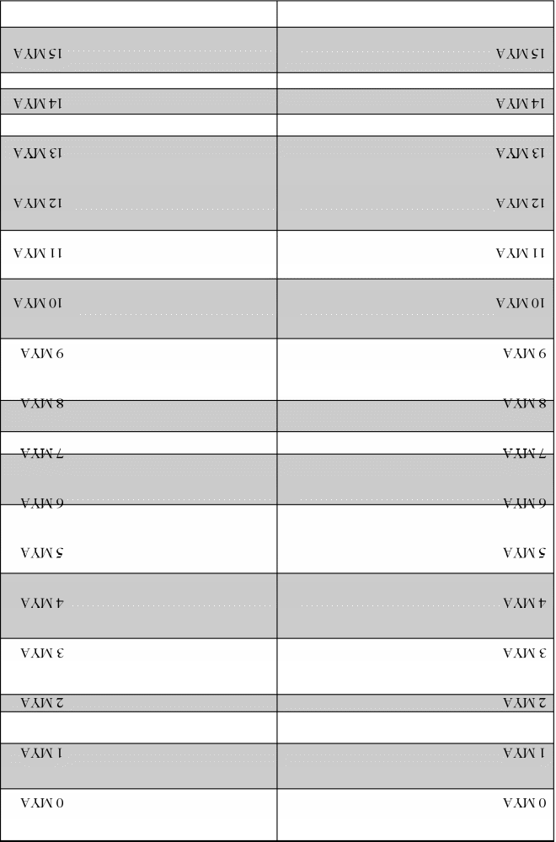
Glue this end to other strip
Glue this end to other strip
Glue this end to other strip
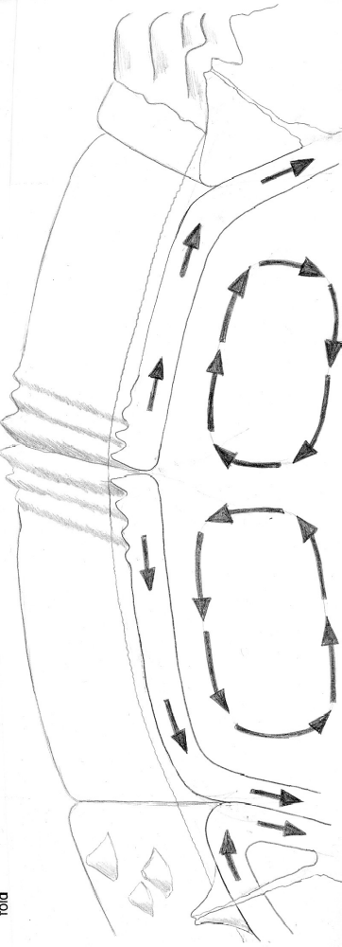
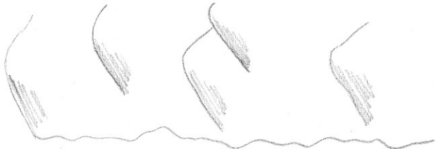
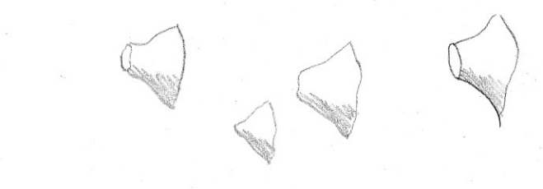
fold
Subduction zone/ trench
Mid-ocean ridge
Subduction zone/trench

